**UT_IT-REPORTS**

TR_01: main ()

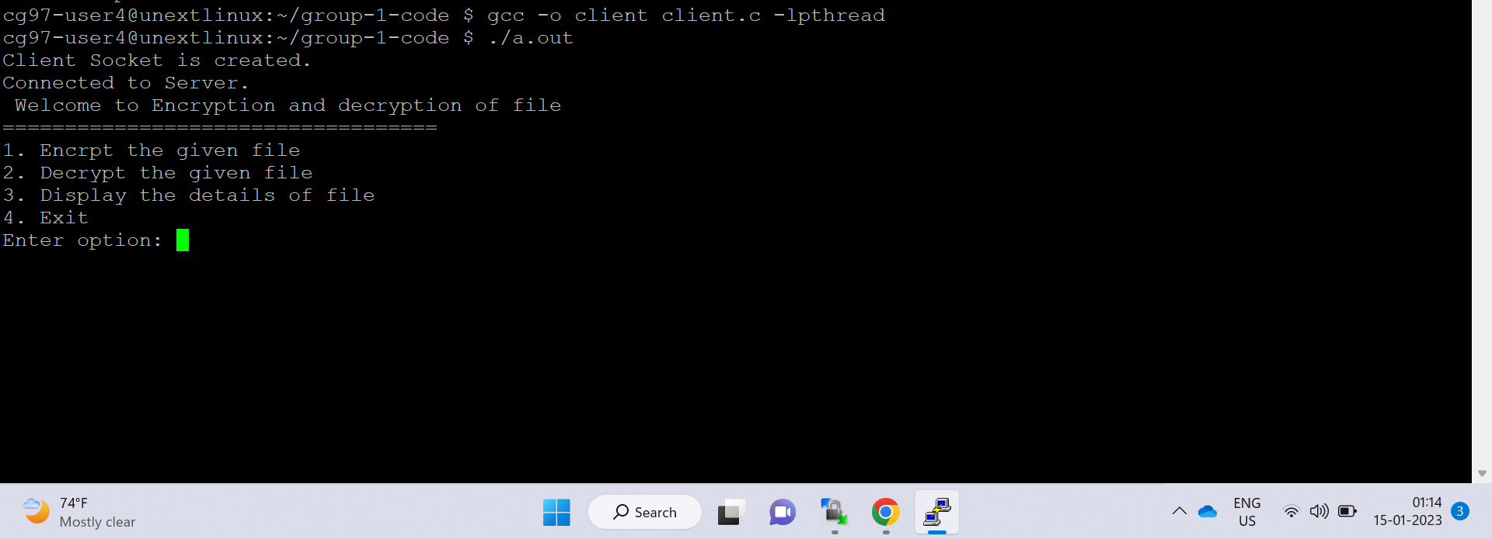

TR_02: main ()

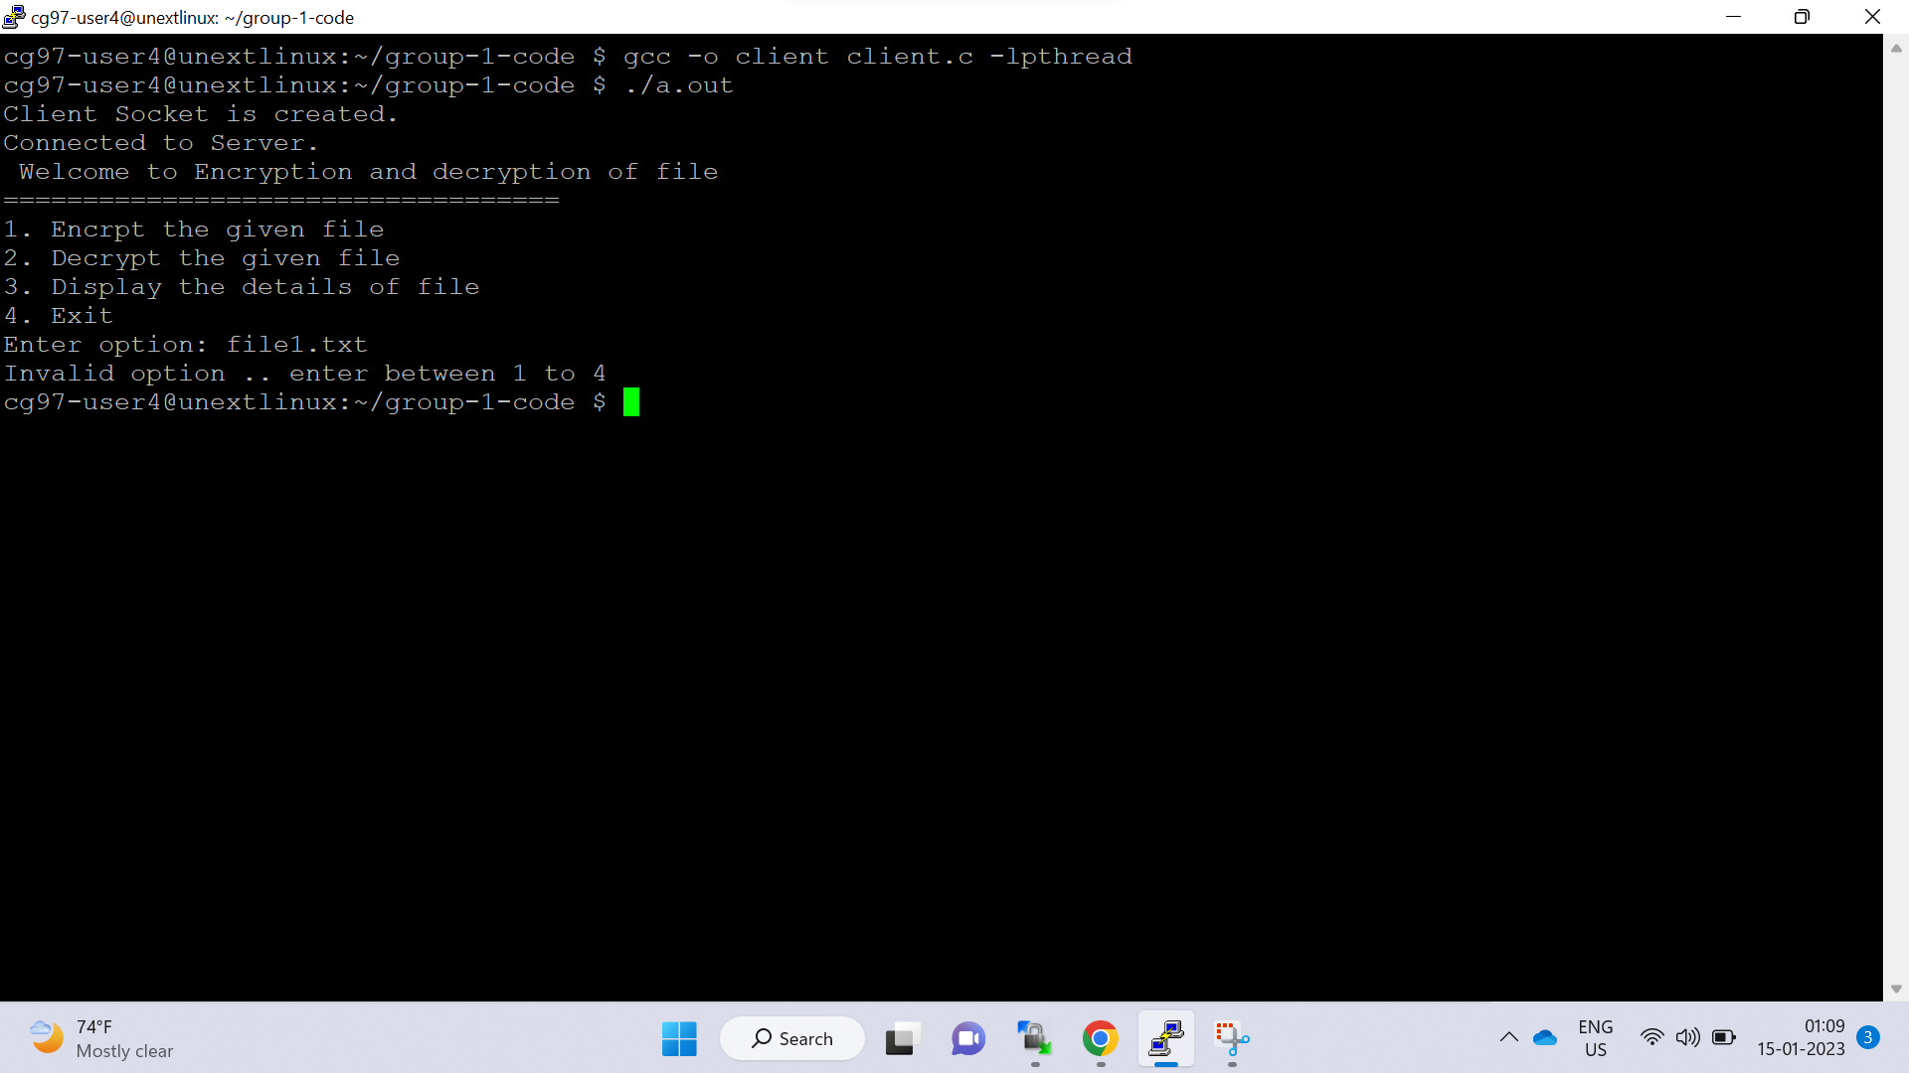

TR_03: encrypt()

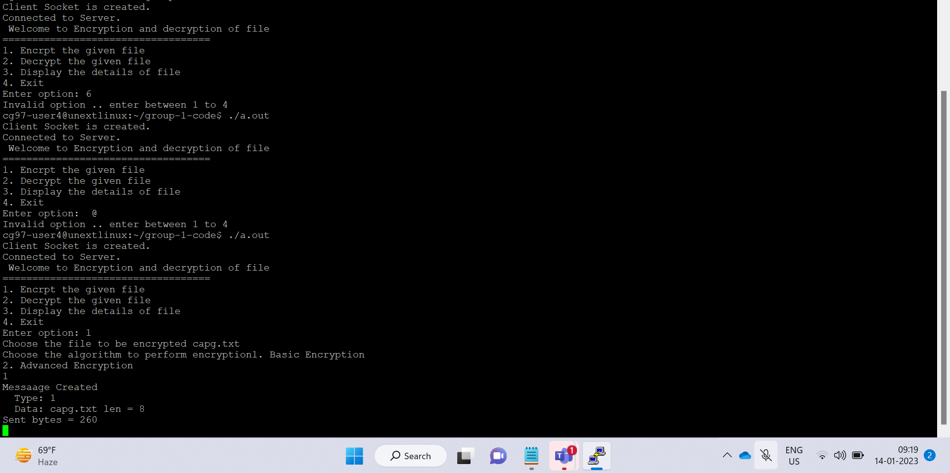

TR_04: decrypt()

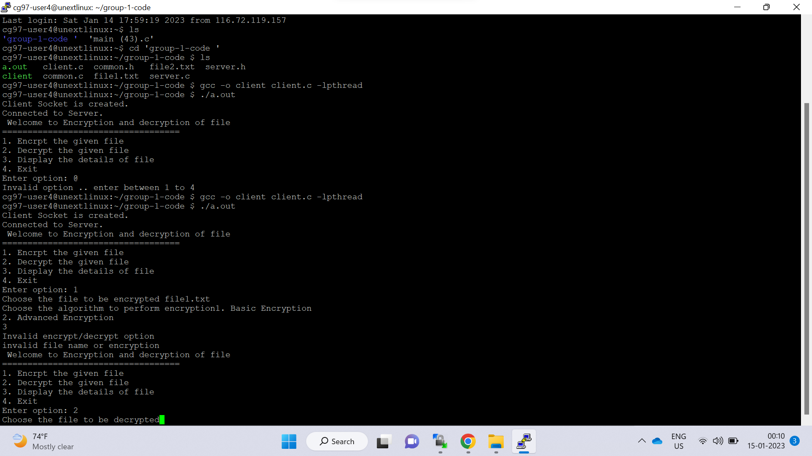

TR_05: basic_encrypt()



TR_06: advanced_encrypt()

